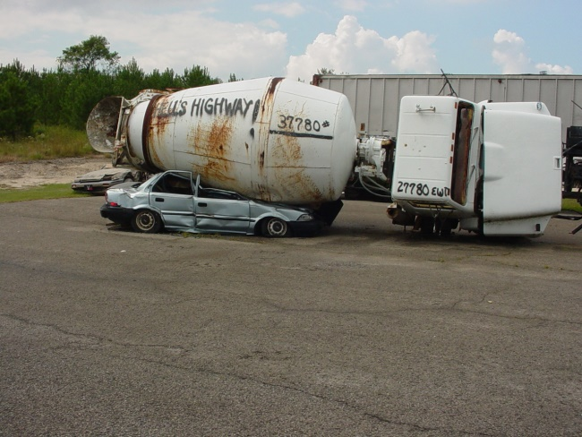
BIG RIG RESCUE™
Overturns and Underrides
Nov 4/5, 2016
Choctaw, OK

Cavin's Towing and Recovery will sponsor a 'basic' BRR program this fall. Beginning at 0800 Friday morning will be a comprehensive, information-packed classroom learning session. Attendees will receive a 300+ page handbook full of details you simply won't find in a single resource except here. This will create a valuable reference document for the future.
After surviving the rapid-fire classroom session you'll be totally immersed in HANDS-ON training. Very challenging scenarios will be staged by the ‘Masters of Disaster’ from Cavin's Towing and Recovery featuring lots of mangled metal. Your team will rotate to each of these scenarios and determine the best tools and techniques to employ. Wicked scenarios like an overturned TT onto a car, garbage packer underride with 'upper' and 'lower' victims, loaded concrete mixer over onto a car, and cargo shift are planned. An experienced instructor will guide you through The 5 Step Discipline for Overturns/Underrides while using a variety of tools.
You're expected to take ownership of the information and form a cohesive team that operates SAFELY and EFFICIENTLY.
The intent is to develop your critical thinking skills, and truly validate the learning process. Sounds almost like boot camp, huh? Nah, it's to craft a rescuer ready for the street. You'll learn about rigging tools, how to use them, plus basic resistance calculations while moving/holding a load.
The presenters are among the BEST anywhere in the country, period. All have true street experience, and fully intend to offer you the ABSOLUTE PREMIER LEARNING OPPORTUNITY. Take a look at the cadre so far…
Billy Leach-Senior Presenter, Wreckmaster 6/7A-R, NCCCO Certified Rigger, Crosby Rigging Trainer, 40+ years of 'street experience', Presenter at Firehouse Expo, FDIC, + international experience, Chairman of Educational Committee for Transportation Emergency Rescue Committee
Each will be very approachable, and will gladly answer questions and assist you.
There is no equal to this training. Join us 'cause we're in it to win it. You can tell others that “Nothing shuts people up like performance.”
The training is sponsored by Cavin's Towing and Recovery, with generous support from many vendors.
You’ll get the opportunity to see and use a variety of hydraulic tools, struts, air lifting bags/cushions and much more.
Attendance will be seriously limited, to provide MAXIMUM HANDS-ON.
Registration is now open. Cost is $200 per person. The event is NON-PROFIT. For more info please email tow5150@aol.com or ring 405.262.3383. Jump in fast!

